University of Pittsburgh at Johnstown

Electrical and Computer Engineering Department SENIOR DESIGN COE1199

Cycle Statistic Tool

Weekly Memorandum
To: | Maddumage Karunaratne
From: | Jacob Hoffman  Cody Klingler

cc:
Date: | 03/01/2021

Re:

Achievements:

Cody: Cody constructed two anemometers and did basic testing. The code for the primary microcontroller has been put together from all of the testing programs that Cody wrote previously. Some of this code was re-written, and the microcontroller program still needs more work done. Cody also tested transferring large amounts of data over Bluetooth Low Energy and did troubleshooting on the display.

Jacob: Jacob programmed the goals page and settings page. Additionally, the performance page has been worked on. Both the goals page and performance page implement list views of all the goal profiles and trips. In the finished goals page, the user can input a new goal profile and edit existing ones. The settings is a modular page with functional controls for the application.

Issues Encountered and Solved:

Cody: The display at one point stopped working and was fixed by re-seating the board.

Jacob: None.

Issues Encountered and Unresolved:

Cody: Transferring large amounts of data via Bluetooth Low Energy failed. Connectivity sometimes dropped and the data transferred was rarely correct. This will need more testing to resolve.

Jacob: The implementation of the SQLite database that Jacob had previously set up is not allowing dynamic data binding for some unknown reason. This means that list views of trips and goal profiles are not automatically updating whenever a change is made. Jacob is working on resolving this by re-designing the SQLite database.

Goals and Tasks For Next Week:

Cody: Cody’s goals are to test more anemometer designs, mount the strain gauges, find a method for filtering inaccurate gear ratio readings, finish microcontroller code, and mount the secondary microcontroller.

Jacob: The first goal for Jacob to complete during this upcoming week is to finish re-designing the SQLite database. This will allow the lists views of goal profiles and trips to update properly. Once this is completed, the performance page can be set up. The bluetooth connection and data collection need to be implemented. This will conclude the requirements for the trip page.

Project Schedule:

Cody: Cody is extending the time for programming the microcontrollers and reducing the time allotted for debugging.

Jacob: Based on the GANTT chart, coding the mobile application should be concluded by 03/08 (next Monday). We are still on schedule. Getting the majority of the application data and UI requirements finished up earlier in the week will allow for more time to be spent on the bluetooth functionality.

Project Logbook:

Cody:
02/20/2021 - 12 hrs

Soldered strain gauge. Glued second strain gauge. Soldered both. Second failed to bond. First one needed a wire resoldered and I accidentally ripped the solder joint off of the strain gauge. Ruined the last strain gauges. Ordered new crank arm, ordered new strain gauges, ordered tool to remove old crank arm. Strain gauges: $20. Crank arm: $13.63. removal tool: $12.99. glue and catalyzer: $11.99.

02/25/2021 - 5 hrs

Constructed 2 anemometers and tested them with a box fan. The best design as far as I can tell is an intact PC fan. Still needs a more rigorous testing.

02/26/21 - 8 hrs

Started putting my test programs together into one large program. rewrote some code and made new functions. debugged display. Tested bluetooth transmission for large amounts of data, which failed. Can't test until Jake is ready. For gear ratio calculation, only accurate while the user is accelerating

Jacob:
02/20/2021 - 4 hours

The databases for storing trip and goal profile object collections were further implemented using SQLite. An individual database table is being used for each object collection. This is a foundational part of the app’s design process since each page the user interacts with will in some way be operating on the two object collections. Additionally, the databases will easily be stored on the user’s device. I am noticing that SQLite is kind of annoying to work with. I believe it is more how I have my design pattern for the app implemented.

02/21/2021 -2 hours

After the trips and goal profiles databases were set up, implementing the goals page began. A main use case of this page is to create a new profile, so this has been implemented. Additionally, the user will be given a list of all goal profiles in the database collection. This has been set up, but there is an issue with dynamically binding the list to the collection. Because of this, the list needs manually reloaded to update it’s contents. This will need to be resolved.

02/22/2021 - 2 hours

Some general options for the application have been added to the settings page. Additionally, the database code was expanded to allow features such as completely clearing all trips/goal profiles. The binding issue has not been fixed yet.

02/25/2021 - 2 hours

The trip view and performance view were worked on. Not much progress was made. The basic layout of the trip page was set up, but it is non-functional.

02/26/2021 - 4 hours

The implementation of the SQLite database was pretty bad and I felt it could be done better. The majority of the database code was re-written. This fixed the dynamic binding issues with the goals list. Additionally, the weekly memo and monthly presentation was worked on by the project team.

Task Division
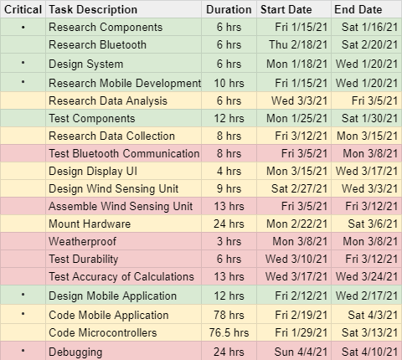
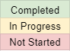
GANTT Chart:

